**Optimal charging/discharging strategies for batteries in smart energy grids**

Paper can be found at: <https://beta.vu.nl/nl/Images/Stageverslag-kooij-sven_tcm235-801707.pdf>

**Chapter 1: Introduction**

This paper looks at three scenarios, one of which is relevant to power laws competition

* Stand-alone price taker battery
* Household with a home battery
* Price makers where a participant in the market has sufficient energy storage to impact the price others pay in the market

*Cited papers applicable to Power Laws competition*

Some of the papers cited deal more with the electricity market as a whole — which aren’t as relevant — while others deal with individual batteries and how they can optimally buy/sell energy to the grid.

**[1]** K. Abdulla, J. De Hoog, V. Muenzel, F. Suits, K. Steer, A. Wirth, and S. Halgamuge. Optimal operation of energy storage systems considering forecasts and battery degradation. IEEE Transactions on Smart Grid, PP(99):1–1, 2016.

Propose a Stochastic Dynamic Programming (SDP) approach to solve the problem of optimally controlling a home battery using an extensive battery degradation model.

* Applicable to problem, but battery degradation doesn’t seem to be involved in the Power Laws competition.

**[18]** C. Keerthisinghe, G. Verbiˇc, and A. C. Chapman. Energy management of pv-storage systems: ADP approach with temporal difference learning. In 2016 Power Systems Computation Conference (PSCC), pages 1–7, June 2016.

Objective is to optimally control an independently owned battery in the hour-ahead market. Use an Approximate Dynamic Programming (ADP) approach because they consider the computation time of the SDP to be too long.

* Pretty much exactly in line with the purpose of the Power Laws competition. The only difference that I can see is the market in Power Laws is 15-minutes, not an hour ahead.

**[6]** Ida Bakke, Stein-Erik Fleten, Lars Ivar Hagfors, Verena Hagspiel, Beate Norheim, and Sonja Wogrin. Investment in electric energy storage under uncertainty: a real options approach. Computational Management Science, 13(3):483–500, 2016.

Use linear programming to optimally control a battery bank in the spot and balancing market, assuming perfect forecasts and applying up to an 11% penalty to account for forecast error. They combine this information with a real options method, simulating the advances in battery technology to determine the ideal moment to invest in storage systems.

* The scope of this paper seems much larger than Power Laws competition, but is still applicable — specifically the first sentence. I wonder if this is more of a “price taker” since it deals with battery “banks”, presumably a large number of batteries working in conjunction with one another.

**Chapter 3: Stand-alone Battery Model**

**3.1 System Description**

The first model describes a home that has a battery which can be charged or discharged in discrete steps in both time and charge – what this means is at certain intervals of time (usually at 15 or 60-minute increments – the paper uses 60-minutes), a battery can choose to charge or discharge depending on the situation at that particular point in time.

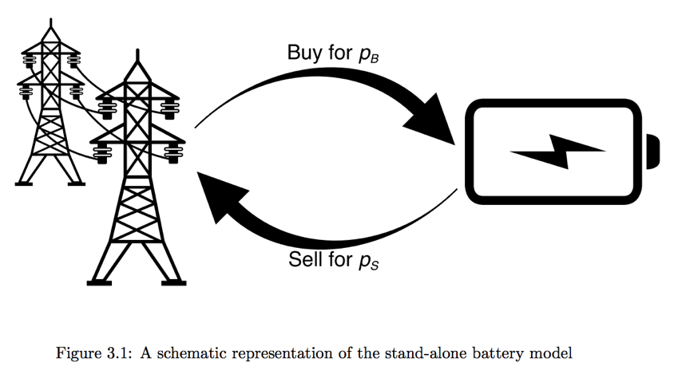

*3.1.1. Electricity Market*

The battery buys and sells electricity from a market, and is considered to be a *price taker*, meaning its actions are insignificant to the system as a whole. The battery can decide several minutes before the start of an hour how much energy it will be using.

We can assume that energy can be bought for $p_{B}$, depicted in this equation

$$p_{B}=\left(1+\left(γ-1\right)1_{\left\{p_{t}>0\right\}}\right)p_{t}+τ$$

There’s lots of moving pieces in that equation, so let’s break it down:

$p_{B}=$ price that energy is bought

$\left(1+\left(γ-1\right)1_{\left\{p_{t}>0\right\}}\right)=$ value-added tax (VAT)

When prices are negative, consumers do not need to pay the tax, which is what the $1_{\left\{p_{t}>0\right\}}$ (the identity function) depicts. When $p_{t}>0$, consumers pay the VAT, otherwise VAT is 0. $γ$ is the tax rate. In the Netherlands, where the paper originated from, the tax rate is 21% so $γ=1.21$

$τ=$ fixed costs of producing the energy

In the Netherlands at the time of publication of this paper, the fixed cost $τ=\frac{0.1007€}{kWh}$

Using Netherlands as an example, the price tends to be 5 cents per kWh

$$p_{B}=\left(1.21\right)p_{t}+\frac{0.1007€}{kWh}$$

$$p_{B}=\left(1.21\right)\frac{.05€}{kWh}+\frac{0.1007€}{kWh}$$

$$p_{B}=\frac{.0605€}{kWh}+\frac{0.1007€}{kWh}$$

$$p_{B}=\frac{.1612€}{kWh}$$

Note that this price of ~16 cents per kWh is in line with prices that you can find [here](https://www.statista.com/statistics/418106/electricity-prices-for-households-in-netherlands/) (the paper was written in November 2016).

*3.1.2. Battery*

The model doesn’t assume the composition of the battery (e.g., lithium-ion, lead-acid, etc.), but rather assigns variables to certain characteristics of the battery. These characteristics of the battery are:

* Total capacity ($x_{max}$) in kWh
* Maximum charging speed ($u_{max}$) in kW

Another way to denote maximum charging speed is its *C-rate*, equal to $\frac{1}{number of hours to fully charge}$. So a battery with a C-rate of 2 means the battery can go empty to fully charged in 30 minute

* Round-trip efficiency ($η$)

*Round-trip efficiency* denotes how efficient the battery is at converting incoming energy into storage and vice versa. For example, most batteries operate on DC current, while the appliances that gets powered by batteries are in AC current. Energy is inevitably lost in this conversion. Additionally, the processes of storing and withdrawing energy from a battery result in energy lost. Round-trip efficiency quantifies how well a battery uses the energy available to it.

* Battery Depreciation

The lifetime of a battery can be described by the number of *charging cycles* it takes for the battery to die. A single cycle is defined as charging 100% of the battery’s capacity and discharging the same amount.

**3.2 Methods**

The goal of the stand-alone model is to decide at each point in time $t$ what to do with the battery in order to maximize the expected profit based on predictions of future prices, $p_{t}$. To solve this problem, we can break it down into different sub-problems:

* The *reward* function which specifies the expected profit at a particular time, given the price and a particular action (either charging or discharging). This is depicted as $R(u_{t},p_{t})$ in the paper

Regarding the reward function for a given action and price, the paper assumes maximum charging/discharging speed equal to $1$. In the competition, all batteries have a charge and discharge efficiency of $0.95$.

The *charge/discharge efficiency* captures the fraction of energy put into storage that can be retrieved. Batteries are not ideal storage devices in that the amount of energy you can take out of a battery is less than the energy that is put in.

As maximum charge/discharge is set to one, the range of possible actions is given by $U=\left[-1,1\right]$. Discharging occurs when $u<0$, while charging occurs when $u>0$.

A related concept is the *cycle cost per unit of charging* ($κ$), which depicts the energy lost when charging the battery, and therefore doesn’t make it into storage.

Other concepts that are included in the reward function are the charge/discharge efficiency, the *cycle costs* depicting how much energy is lost while charging, and the price

* Given the output of the reward functions for all possible actions, we select the action that maximizes profit. This is depicted as $V_{t}^{*}(x_{t})$ in the paper

If the prices were known at all time horizons, this would be a straightforward problem to solve. However, as we need to take into account future prices when maximizing profit for the current time period, we need to deal with uncertainty. The papers assumes there are forecasts for $p_{t}$ up to $L$ periods ahead for every point in time, with each of these forecasts having an independent error distribution from a known probability function, $f_{p_{t}}(p_{t})$

The paper continues with incredibly dense mathematical representations of how to calculate the optimal expected decision for time $t$. It is hard to follow, but a key component of solving this optimization problem is to make the charging/discharging actions discrete instead of continuous. The decision is between buying energy for the battery, selling energy from the battery, or doing neither. In a continuous scenario, it would be possible to partially (dis)charge the battery.

The total value of expected best decisions is given by (TODO: provide explanations of what each variable is doing here):

$$V_{total}=\sum_{t=1}^{T}{({\hat{U}}_{t}\left(x_{0}+\sum_{i=1}^{t-1}{{\hat{U}}_{t}},p_{t}\right),p_{t})}$$

*3.2.1. Lower Bound*

To show the added value of using forecasts in our models, we will use models that do not make use of forecasts as lower bounds (aka baselines to improve upon).

* Daily Pattern

One method to baseline any model is to look at the average daily price trends taken over an entire year. If it takes $n$ hours to fully charge a battery empty to full, the strategy is to find the $n$ cheapest hours to charge.

* Threshold

Another method is to use threshold values – if the price of energy is below a certain threshold, energy will be bough. If the price is above a certain threshold, it will be sold. To ensure that we will never lose money on our investment, we’ll choose the top and bottom price thresholds that are equidistant from the mean.

**3.3 Data**

*3.3.1. Electricity Market*

The research considered a scenario with increased renewable energy penetration. In order to answer the questions that serve as the purpose of this paper, data about the following is needed:

* Energy Price
* Renewable Penetration
* Link between renewable penetration and energy price
* Hourly price forecasts

This data wasn’t available all in one data set, two separate data sets from Germany and Belgium respectively were incorporated into the analysis.

* Data exploration

*Subheader*

Lists:

* Bulleted List

1. Numbered List